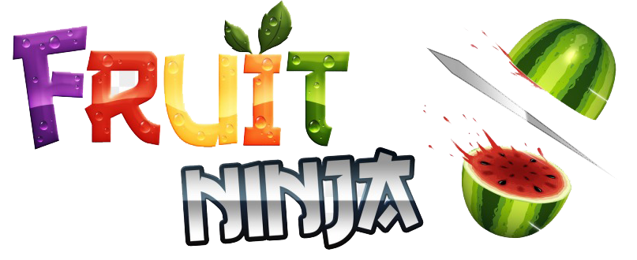

**User Guide**

**General Game Instructions:**

For starters , the user would have to choose whether to start a new game or continue the game he previously left unfinished (in case he/she has played the game before).

During the game, there would be a pause button at the top center of the screen to give the user three options, whether to return back to the home screen, restart or resume the game.

The main aim of the game is to beat your own high score in either Classic or Arcade mode. As the user plays the game for the first time, best score would be 0 and keep increasing alongside the current score. However, the next time the user plays the game, the best score shown to the user would be that of the previous game, it will be constant throughout the whole game unless the user exceeds it.

Regarding the game's difficulties, the user will witness a change in the game's difficulty every time his/her score increases by 50. The change in difficulties will be observed by seeing how fruits and bombs pop on screen more often and with greater velocity.

Current score, best score, remaining lives and time reached by the user are saved whether the user paused the game to then give him/her the ability to continue his/her unfinished game or when the user's score is multiples of 20 as this is considered a checkpoint.

**Regular Game Fruits:**

**The following fruits increase the user's score by 1 point when sliced:**

1) Apple

2) Watermelon

3) Lemon

4) Orange

5) Strawberry

**Special Game Fruits:**

**The two following fruits increase the user's score by additional points when sliced in comparison to the regular fruits:**

1) Pineapple 🡪 10 points

2) Coconut 🡪5 points

**Game Bombs:**

1) Dangerous Bomb deducts 1 life when sliced in Classic mode.

2) Fatal Bomb ends the game when sliced in Classic mode.

**Classic Mode Instructions:**

In Classic mode, the user has 3 lives that are lost by either slicing a dangerous bomb or missing a fruit without slicing it, each deducts one life. However, fatal bombs end the game immediately whenever they're sliced even if there are lives remaining.

There is no specific time limit for playing in Classic mode, the timer is only shown to the user to know for how long he/she has been playing.